Materials
A mechanical engineer uses different materials to build machinery or tools. A specific knowledge of materials is required, concerning qualities, properties, costs and general characteristics
- Match each object with its material
Objects | Material
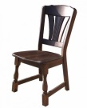 | Ceramic
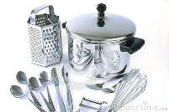 | Wood
 | Gold
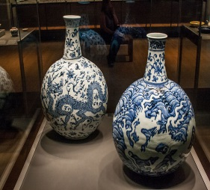 | Plastic
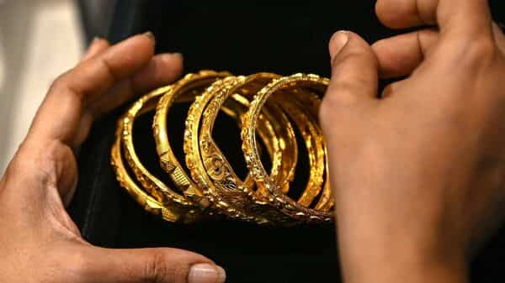 | Steel
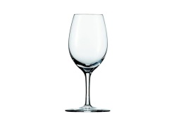 | Glass

When a machine or a tool is made, the most suitable materialmust be chosen by considering its properties, which can be classified as mechanical, thermal, electirical and chemical. The main types of materials used in mechanical engineering are metals, ceramics and composite materials. The most commonly used materials are metals, which can be divided into ferous and non-ferous. They can be used in their pure form or mixed with other elements. In this second case we have an alloy and it is used to improve some properties of the metals. The most commonly used ferrous metals are iron and alloys which use iron. Because iron is soft and pasty, it is not suitable to be used as a structural material. So, a small amount of carbon is added to it to make steel alloy.
Non-ferrous metals used contain little or no iron. The most common non-ferrous metals used in mechanics are cooper, zinc, tin and alliminium. Some common non-ferrous alloys are brass formed by mixing (cooper and zinc). Bronze (formed by mixing cooper and tin) and other alliminium alloys which are used in the aircraft industry. Other examples of materials used in mechanical engineering are plastic and rubber.
PVC or polyvinyl chloride is a type of plastic used to insulate wires and cables. Rubber is a polymer and its best property is elastucity, as it returns to its original size and shape after deformation. Ceramic materials are good insulators; hard resistant, and strong, but brittle.
Composye materials are made up of tto or more materials cobined to improve their mechanical properties.concrete is reinforced with steel and is used in building engineering.
2- Read the text again and match the words with their definitions
- Alloy a type of plastic used in insulation
- Steel a combination of different metals
- PVC an alloy formed by mixing iron and carbon
- Concrete an alloy formed by mixing cooper and zinc
- Brass metals containing iron
- Ferrous material a composite material used to build houses
- Ceramic a metal not suitable as structural material
- Iron a good insulator but brittle
3- Read the text again and answer the questions
- What is the basic classification of metals?
- What are the characteristics of iron
- Why are alloys created
- Which materials are good insulators
- Is steel an alloy? Which metal does it contain?

4- Complete the definitions with the words in the box
Cooking, coins, alloy, cooper, wires, steel, carbon, gold, expensive, ductile.
Iron: its Latin name is ,ferrum. It is magnetic and ha a silvery colour. In prehistoric times it was used to make ornaments and weapons. If exposed to the ………………………, it oxidizes.
………………………..: it is one of the most widely used metals by humans. In prehistoric times it was used to make cooking utensils ………………………… and ornamental objects. It is used in …………………….and cables.
……………………………….: it is the most ……………………metal and is used to create precious jewelry.
It is the most ……………………….metal.
It is an ………………………formed from iron and ……………………………. It can contain between 2.1% carbon. It is also used for …………………………..utensils and pans.

- Complete the following diagram

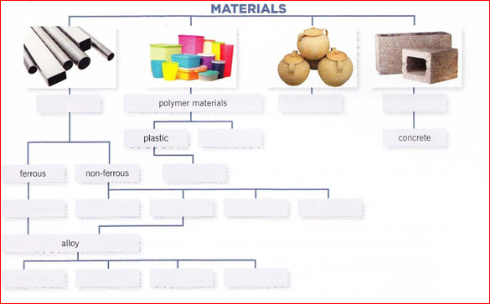
7. Write a summary of texts in exercises 1 and 4following the given plan
The importance of having knowledge of materials in engineering, list the materials and the main groups used in mechanics, tell the difference between ferrous and non-ferrous metals, what is an alloy and what is it used for , a list of non-ferrous metals and alloys.

